***Day 3 API Integration (Furniture)***

# 1. Introduction

This report documents the integration process of migrating external data from a REST API into the Sanity CMS for "Hekto," a furniture e-commerce platform. The goal is to automate content management for products such as sofas, chairs, office desks, and other furniture categories, ensuring seamless backend updates and synchronization with the Next.js frontend.

Key objectives include:

* Fetching product and category data (furniture-related) from an external API.
* Structuring and migrating this data to Sanity CMS.
* Displaying the migrated data dynamically on the frontend.

## 2. API Integration Overview

* ***API Name:*** *The external marketplace API, hosted at: https://next-ecommerce-template-4.vercel.app/api/product.*

*●*

* ***Data Fetched:***

*○* ***Products:*** *Details such as product titles, prices, descriptions, categories (e.g., sofas, chairs), images, etc.*

*○* ***Categories:*** *Furniture categories like "Sofas" "chairs”, etc., associated with products.*

* ***Sanity Client:*** *Used to manage and store fetched data in the CMS, ensuring compatibility with the defined schema structure*

## 3. Schema Structure Changes

*The product schema was enhanced to better represent furniture product details. Key updates include:*

*By MOHSIN ALI*

***Updated Fields:***

* ***name (string):*** *The furniture product’s name (required).*
* ***image (image):*** *Images showcasing each furniture item.*
* ***price (string):*** *The product price (required).*
* ***description (text):*** *A brief product description (max 150 characters).*
* ***discountPercentage (number):*** *The discount percentage (0 to 100).*
* ***isFeaturedProduct (boolean):*** *Flag indicating if the product is featured.*
* ***stockLevel (number):*** *Tracks stock levels (must be positive).*
* ***category (reference):*** *Links products to specific furniture categories.*

***Snippet of Updated Product Schema:***

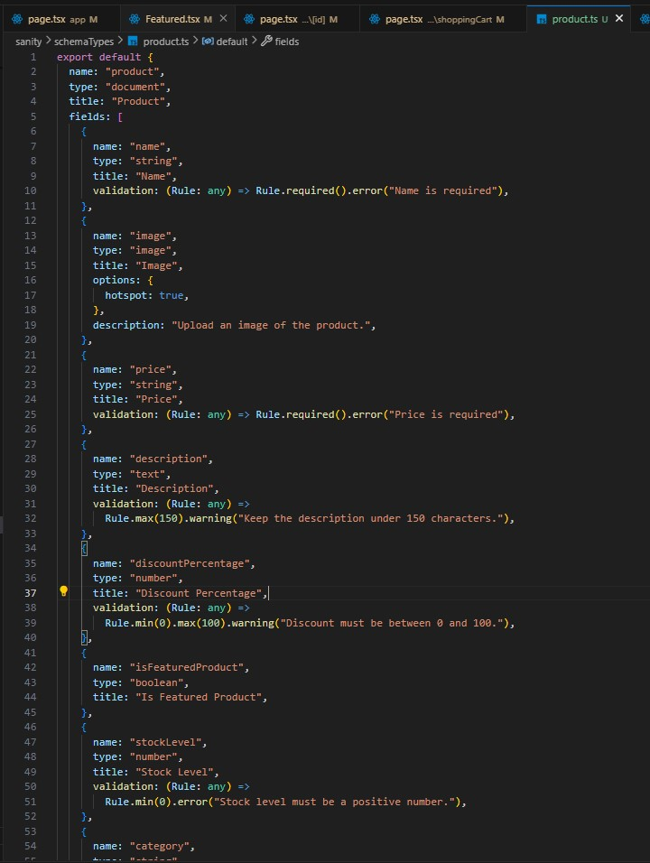

## 4. Migration Steps and Tools Used

***Tools Used:***

1. ***Sanity Client:*** *To interact with the Sanity CMS (via @sanity/client).*
2. ***Node.js & Fetch API:*** *For fetching data from the API and uploading it to Sanity.*
3. ***Environment Variables:*** *For secure storage of sensitive data like API tokens.*
4. ***Sanity Image Tool:*** *To upload and manage furniture images in the CMS.*

***Migration Steps:***

1. ***Set Up Environment:*** 
   1. *Installed required dependencies: @sanity/client, dotenv.*

*○ Configured .env.local for secure storage of API keys.*

1. ***Sanity Client Setup:*** 
   1. *Created a sanityClient instance using project ID, dataset, and API token.*

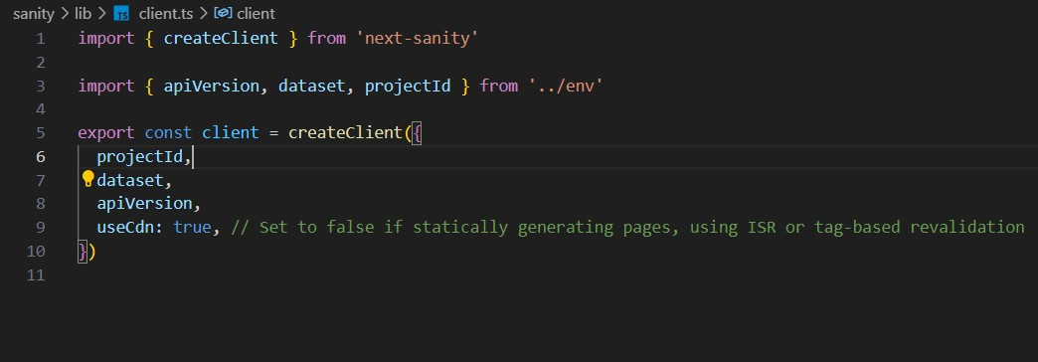

1. **Fetch Data from API:**

**● Used fetch to retrieve furniture product and category data from the API.**

*By MOHSIN ALI*

**4. Upload Images to Sanity:**

**● Uploaded furniture images using the Sanity asset pipeline and retrieved asset IDs for linking.**

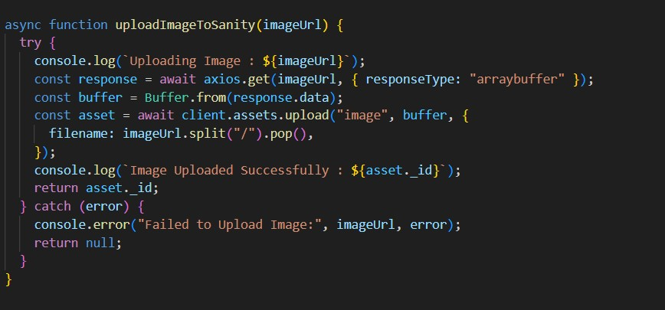

# (Screenshot )API call in response

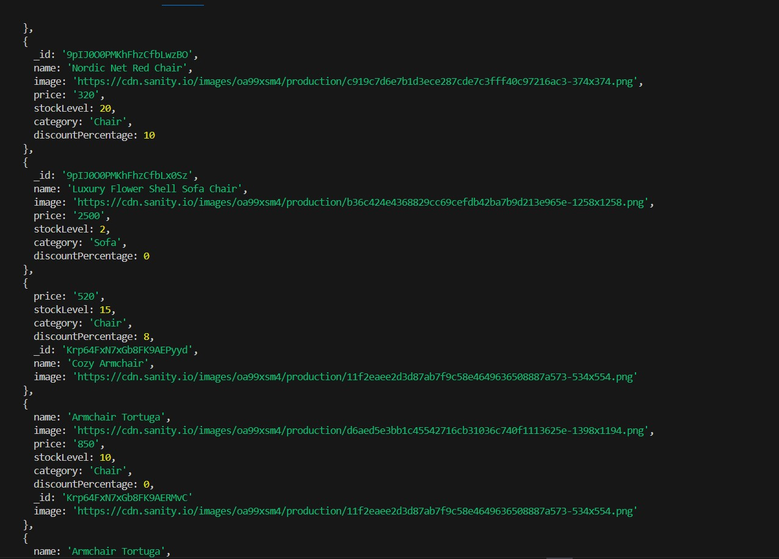

***Data successfully display in Frontened***

# (Latest Products)

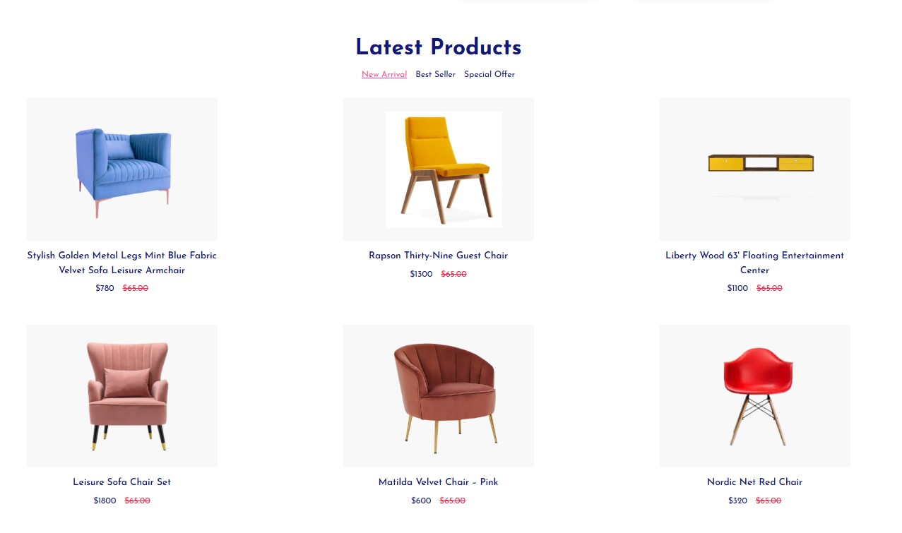

# (Featured Products)

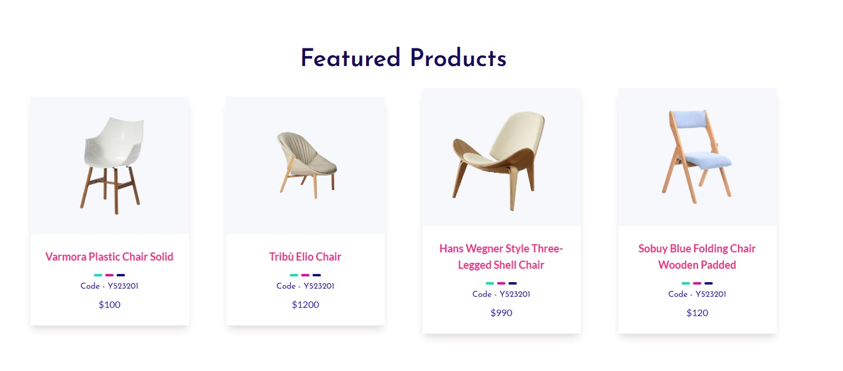

*By MOHSIN ALI*

***Code Snippets for API integration and (Migration Script):***

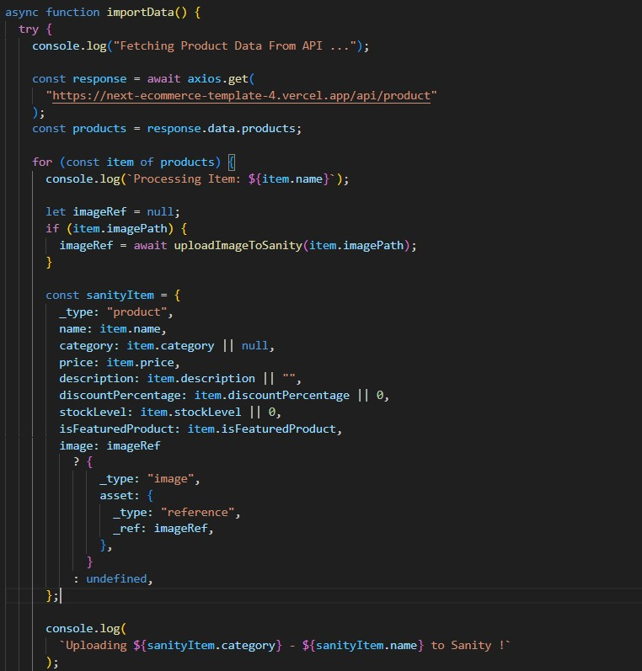

*By* **MOHSIN ALI**

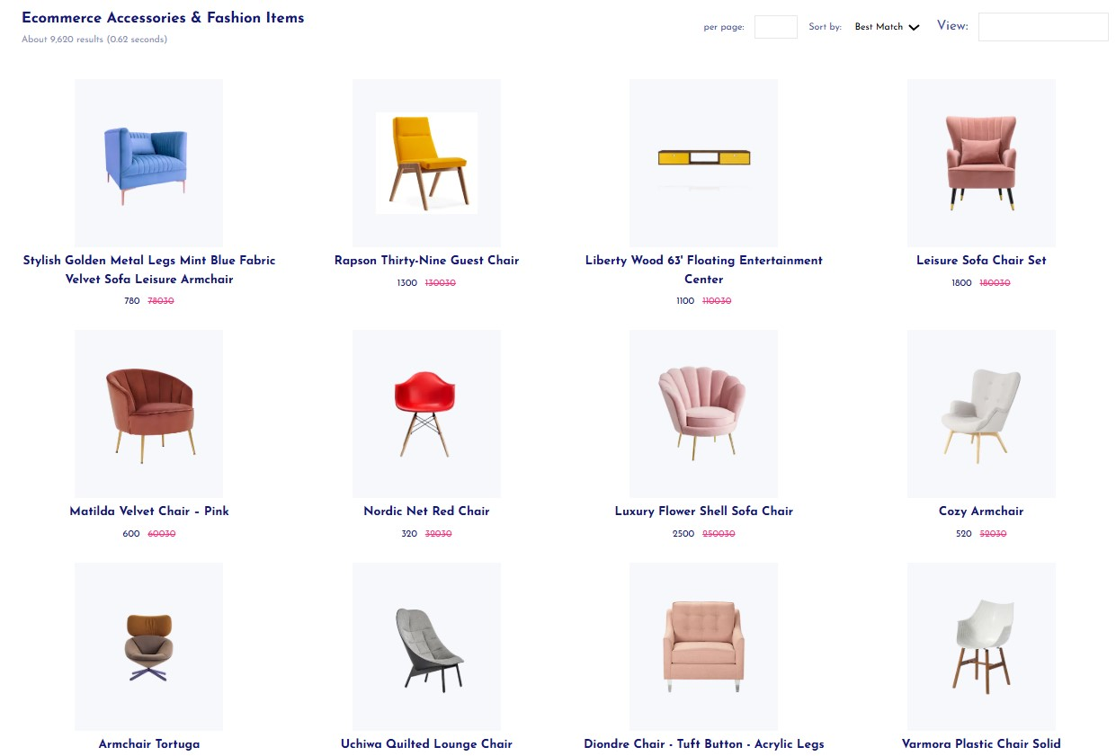

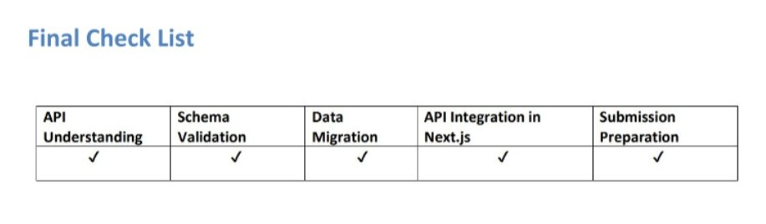

*By MOHSIN ALI*